**Stay Faded Barbershop**

1. Introduction

• Briefly describe the key features of your project.

Visitors will visit this site to look for a barbershop they can call home. There will be easy navigation, scheduling, and a community feel to the experience. This is a Cleveland barbershop, and I want each user to take pride in this city.

2. Design and Implementation

Give a detailed description of the design and implementation of your project.

The design should include a consistent jumbtron (thats not too flashy), but displays a logo that is consistent throughout the site. The NavBar should take the user to the major components of the business such as booking, gallery, contact info, possibly customer feedback and reviews.

In particular, this section should contain:

The “HOMEPAGE” will give a brief snapshot of each component of the website without too much emphasis of any area. The key feature of the homepage will have a carousel which I plan to make the focal point.

----

The “GALLERY” page will display submitted work from satisfied customers and barbers. It should display varying types of cuts and allow the visitor to get a realistic feel to the services offered.

The “SERVICES” page will show a catalog of different types of haircuts. Instead of displaying just a type of haircut and price, the visitor will see a photo of the style of haircut. The services page will also give a brief description of that particular style and price. There are MANY types of haircuts, and I think the user would be far more confident in knowing exactly what they want … or maybe try something new. The SERVICES page should also have an option to see a plan catalog with a basic listing view and price. I think this will give the offered services a “spin” on selection.

I also planning on possibly adding a tab to separate the haircuts versus braids and twists. Seeing that the shop offers both services, the difference between getting a haircut versus braids is significant in required skillset and cost. So they should be on two separate tabs.

----

The “CONTACT” page should have a large “splash” image at the top. The splash image should be team oriented in nature. (Maybe a group of barbers working in a shop or group photo?) Beneath that, a grid that breaks down each barber with specific contact information.

The “CONTACT” page should also have a section to allow someone to apply for a job at the shop. The hiring portion should be referenced somewhere on the homepage.

----

• Details of how you converted from design to the actual realization of your project in terms of implementing the code.

I took the framework from our bootstrap course and modified it by pulling out components and putting in bootstrap components and code snippets that I found on the web. I used babel to convert the ES6 snippets to ES5 to allow uglify to minify the script for distribution.

• Any choices that you made, and any modifications that you made to the design, in response to difficulties that you might have encountered while implementing the project.

Bootstrap didn’t have a gallery component that met the specific needs of my design. I ended up going online and trying various galleries with a lot of difficulty implementing them. I would say that most of them did not work out the box, but I found one that I understood and implemented.

Additionally, I found CSS scripts that sharpened the display of the bootstrap template.

• A brief discussion of various components that you used in implementing your project, and the reasons you chose them over alternatives.

I used the Bootstrap Tab component to separate the haircuts from braids. I used CSS to modify the background, and applied CSS to areas that were repeated in the design. I used the style attribute for CSS where the application did not repeat. For bootstrap, I specifically used the carousel, and I replaced the default boostrap nav with nave bar with a predefined design.

• Include a few screenshots of your website in the report.

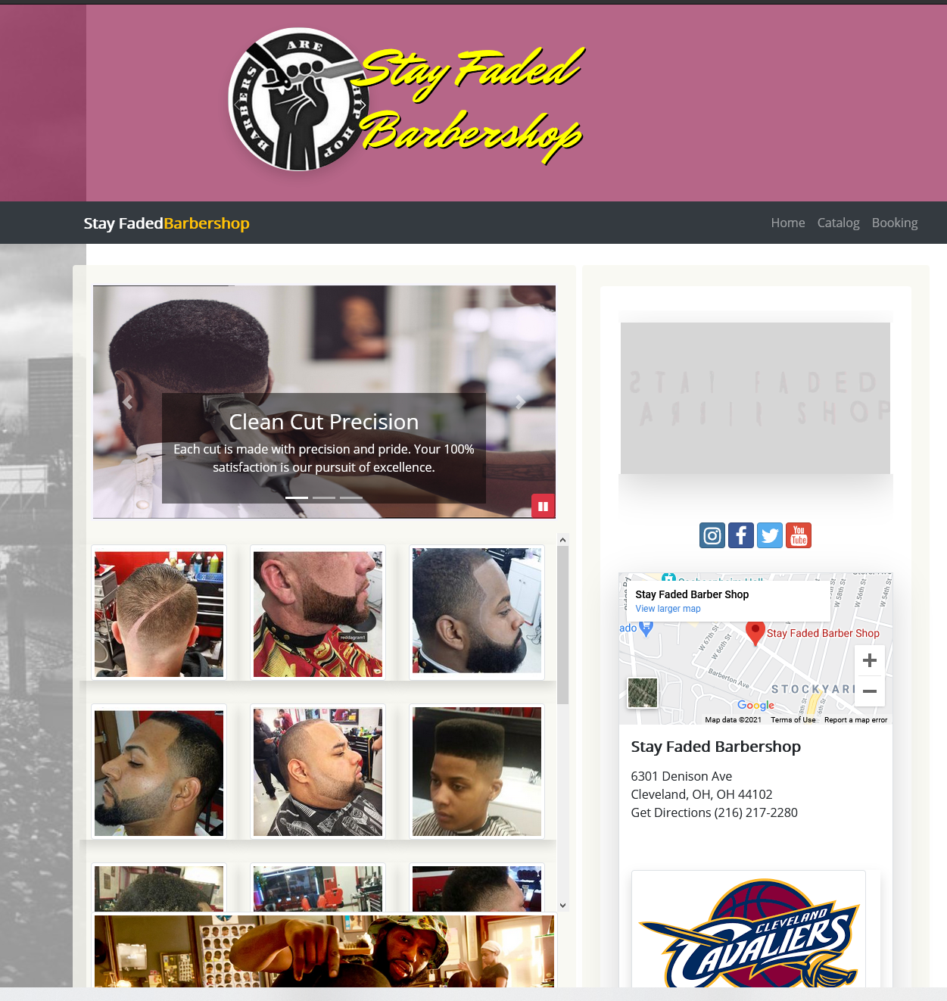

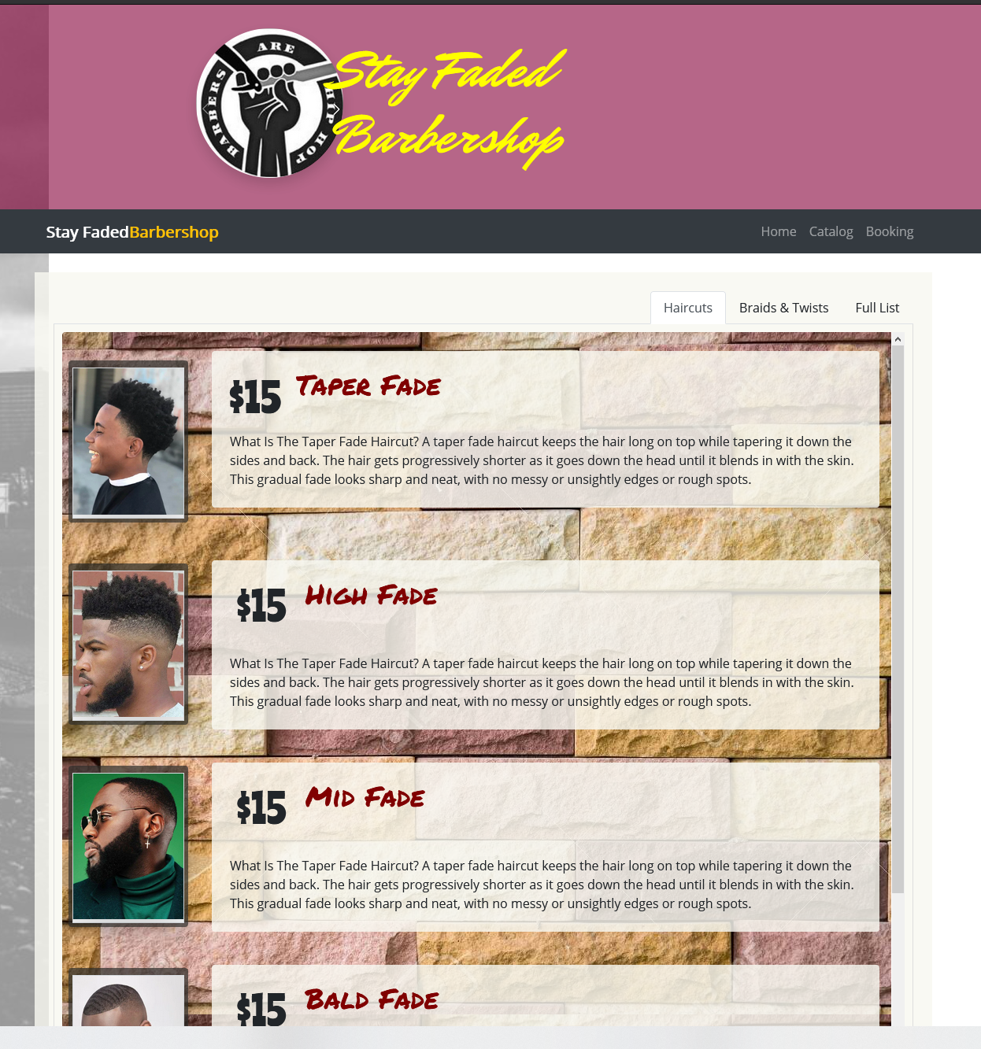

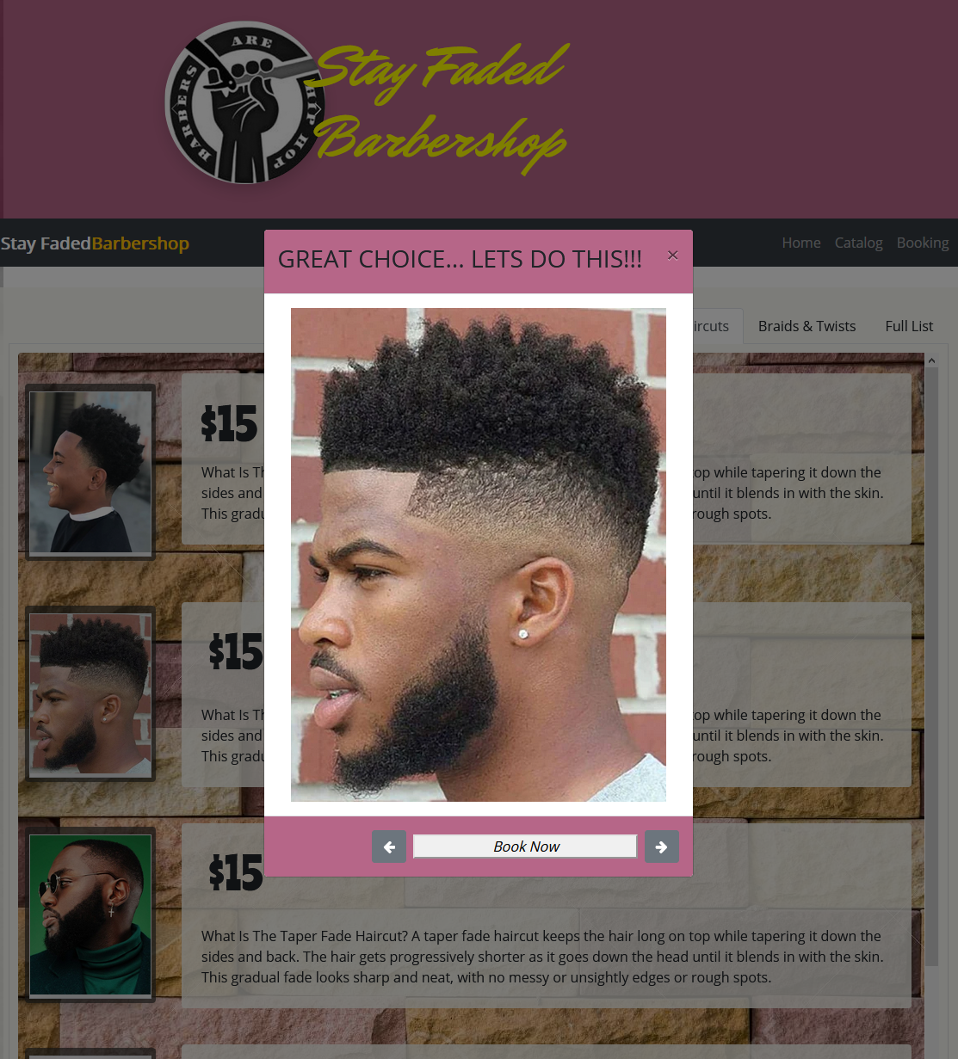

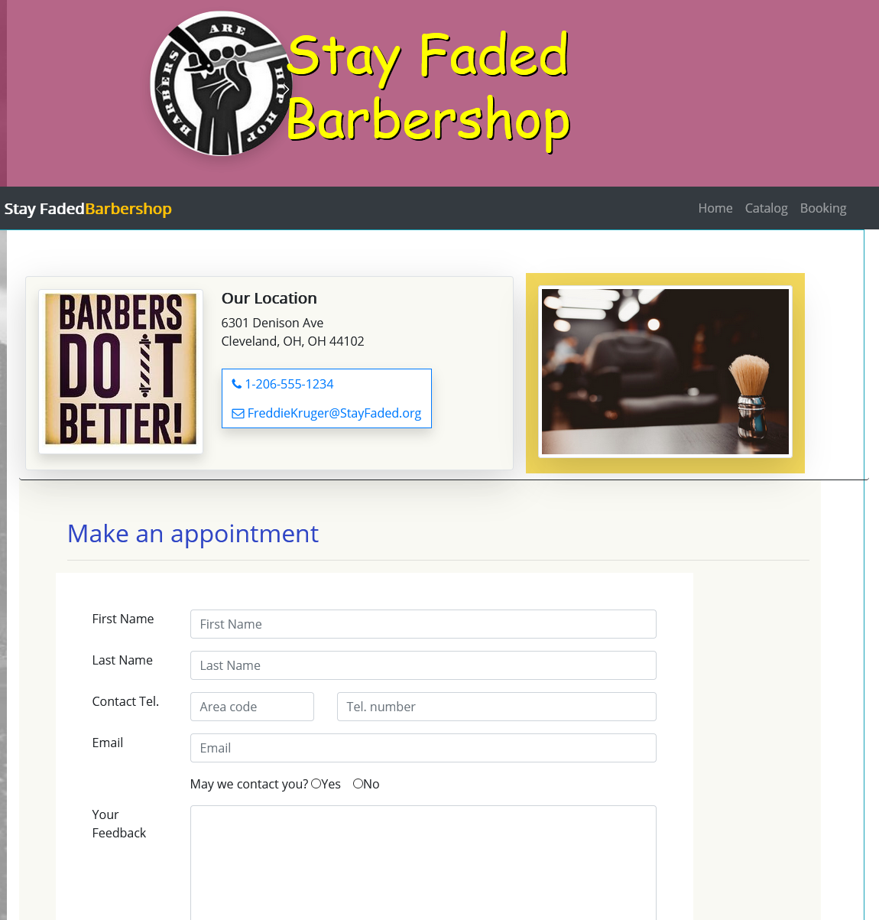

3. Conclusions

• Discuss what you personally learned from your project.

I learned that I have to break away from thinking in HTML and start using the benefits of bootstrap. I learned that I can get ideas out in a uniform way and much quicker using the tools available. I also learned to take advantage of CSS. I personally understand the fundamentals of javascript which allows me to look at snippets and have a basic understanding of what the code is doing

• Discuss the best features and the shortcomings of the project

If it was up to me, I would never be satisfied with what I develop. I have to learn to curve my ideas and focus on the intent of the site. I think the best feature is the catalog which allows users to see what haircut options they have, and they know they always have the option to get something different. The shortcoming is the contact page which needs more work, and the footer which I spent zero time on.

Discuss any choices that you might have made differently, in hindsight after completing the project.

I would have kept the viewports under consideration during the build phase of the site. I realized that after I designed the site, when I shrink the screen down … the different components overlap and it doesn’t look good on a phone for example. So, I learned that I have to keep the component, row, column in mind and how the elements I place in them impact every view port size. From col-lg to col-xs, I should continually check that for every component I add to a page.